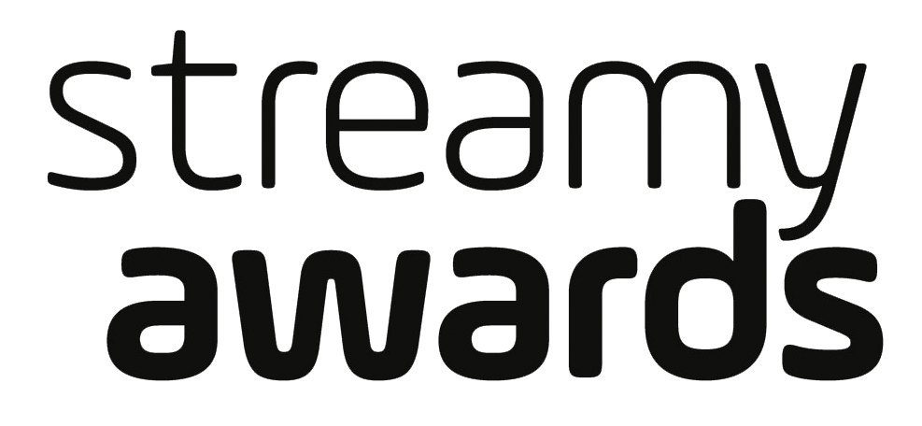

DICK CLARK PRODUCTIONS AND TUBEFILTER ANNOUNCE THAT
SUBMISSIONS ARE OPEN FOR THE 6TH ANNUAL STREAMY AWARDS

For Streamy Awards photos and video assets, please go to: http://bit.ly/Streamys16Content

Los Angeles, CA (June 20, 2016) – dick clark productions, one of the world’s largest producers and proprietors of televised live event programming, and Tubefilter, the leading resource for YouTube and online video news, analysis, and events, announced that submissions are now open for the 6th Annual Streamy Awards, honoring the best in online video and the creators behind it. The 6th Annual Streamy Awards will feature three new categories: Virtual Reality and 360° Video, Live, and Feature. Nominations will be announced in August, and the 6th Annual Streamy Awards will be held this fall.

“Innovation has always been a hallmark of the online video community,” said Streamy Awards Creator Drew Baldwin. “Our new awards reflect the pioneering spirit and current state of the industry, while also embracing the passion and engagement of online video creators.”

“This year marks the fourth year that dick clark productions and Tubefilter have brought together creators, fans and the industry for the Streamy Awards,” said Ariel Elazar, Executive Vice President of Brand, Marketing, and Digital Strategy for dick clark productions. “Digital creators continue to be a vital component to entertainment across all platforms, and we look forward to growing upon the success of last year’s show.”

Submissions for the 6th Annual Streamy Awards open today at www.streamys.org and close 11:59 pm PT on Monday, July 18, 2016.

Continuing to reflect the current state of original programming native to online and social video, the 6th Annual Streamy Awards will feature new and updated awards, including:

- Virtual Reality and 360° Video award, recognizing the trailblazers utilizing the latest technologies in the digital space.
- Live, an award celebrating shows, channels, and events happening in real time.
- The Feature award, acknowledging creator driven, feature length movies.

The full list of awards categories for the 6th Annual Streamy Awards is available at: www.streamys.org/categories.

Recognizing the critical role that fans play in the digital community, the Streamy Awards will once again allow the public to choose one of the five official nominees in each category. Fan Nominations for all categories will open on Monday, July 11, 2016. The entrant in each category with the most fan nominations will automatically become one of the nominees. In addition, two Audience Choice Awards—Entertainer of the Year and Show of the Year—will be determined entirely by fan vote.

“Audience engagement and interaction is a cornerstone of online video,” added Streamy Awards Creator Josh Cohen. “It’s important for us to give our audience the opportunity to help determine and honor the best creators and content in the space.”

Streamy Awards winners are determined by the Streamys Blue Ribbon Panel, comprised of a select group of leaders shaping the future of entertainment. They include creators, executives, and other experts in the online video industry.

The 5th Annual Streamy Awards were the #1 most social non-sports program on TV on the day the show aired. More than 97,000 people wrote almost 475,000 Tweets about the 5th Annual Streamy Awards, and 2.3 million people saw those Tweets a total of 9.3 million times. (Source: Nielsen).

For more information, visit www.streamys.org. Join the conversation on Twitter with @streamys using #streamys; follow Streamy Awards on Facebook, Instagram, Tumblr, Vine as well as Snapchat – username: streamys.

About the Streamy Awards
The Streamy Awards honor the best in online video and the creators behind it. The annual event brings together the biggest names in YouTube and online video for a night of celebration, discovery, and meaningful recognition. 2016 also marks the first ever international version of the show, Streamys India, in partnership with Culture Machine.

About dick clark productions
dick clark productions (dcp) is the world’s largest producer and proprietor of televised live event entertainment programming, with the “Academy of Country Music Awards,” “American Country Countdown Awards,” “American Music Awards,” “Billboard Music Awards,” “Dick Clark’s New Year’s Rockin’ Eve with Ryan Seacrest,” “Golden Globe Awards,” “Hollywood Film Awards” and the “Streamy Awards.” Weekly television programming includes “So You Think You Can Dance,” from 19 Entertainment, a division of CORE Media Group and dcp. dcp also owns one of the world’s most unique and extensive entertainment archive libraries, with more than 55 years of award-winning shows, historic programs, specials, performances and legendary programming. For additional information, visit www.dickclark.com.

About Tubefilter
Tubefilter is the leading resource for YouTube and online video news, analysis, and events, including the Streamy Awards (streamys.org) and Stream Con NYC (streamconnyc.com). For additional information, visit www.tubefilter.com.

Media Contacts:

dick clark productions
Liz Morentin, 310-255-4602, lmorentin@dickclark.com
Lydia Baskharoon, 310-255-0319, LBaskharoon@dickclark.com

MPRM Communications
Michelle Marron, 323-933-3399, mmarron@mprm.com
Jackie Cavanagh, 323-933-3399, jcavanagh@mprm.com

# # #

The 6th Annual Streamy Awards recognize excellence across forty-four categories, including two Audience Choice Awards chosen entirely by members of the public.

Overall (10)
Virtual Reality and 360° Video (New Category)
Animated
Breakout Creator
Comedy
Drama
Feature (New Category)
First Person
Indie
International
Non-Fiction

Subject (13)
Action or Sci-Fi
Beauty
Documentary or Investigative
Fashion
Food
Gaming
Health and Wellness
Kids and Family
Lifestyle
News and Culture
Pranks
Science or Education
Sports

Performance (5)
Actor
Actress
Collaboration
Dance
Ensemble Cast

Music (3)
Breakthrough Artist
Cover Song
Original Song

Craft (6)
Cinematography
Costume Design
Directing
Editing
Visual and Special Effects
Writing

Social Video (3)
Live (New Category)
Snapchat Storyteller
Viner

Campaign (2)
Brand Campaign
Social Good

Audience Choice (2)
Entertainer of the Year
Show of The Year

