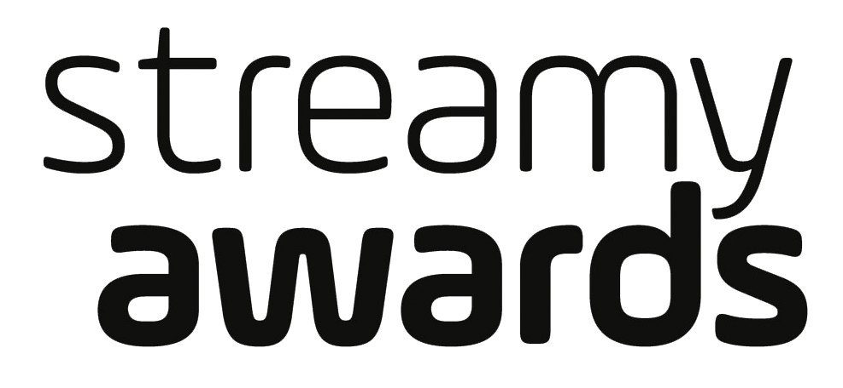
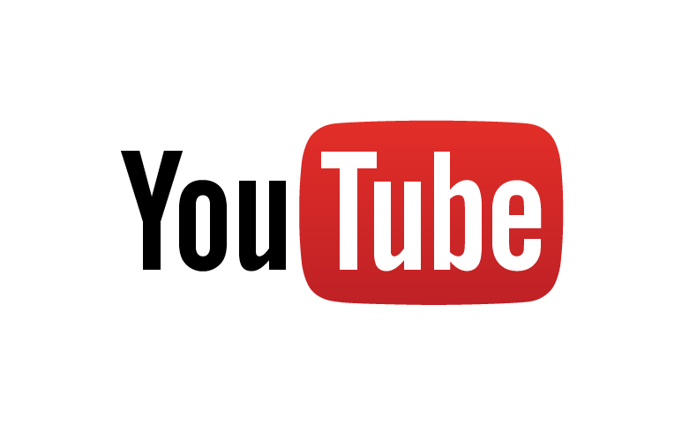
YOUTUBE TO SERVE AS GLOBAL LIVE STREAMING PARTNER FOR THE 6TH ANNUAL STREAMY AWARDS ON
TUESDAY, OCTOBER 4, 2016 AT 9PM ET / 6PM PT

YouTube Mobile Live Streaming Will Offer Exclusive Red Carpet Access
for Fans to Connect Directly with Presenters and Nominees
During the Show

Flula Borg, Shay Carl, Yousef Erakat, HolaSoyGerman, Jenn McAllister,
Logan Paul, Anthony Padilla and Ian Hecox of SMOSH and
James Van Der Beek Added as Presenters

LOS ANGELES, CA (September 27, 2016) – dick clark productions, one of the world’s largest producers and proprietors of televised live event programming and Tubefilter, the leading resource for YouTube and online video news, analysis and events, have partnered with YouTube, the world’s largest video sharing platform, to exclusively live stream the 6th Annual Streamy Awards. The annual awards show, which honors the best in online video and the creators behind it, will be hosted by television and online multi-hyphenate King Bach and will live stream on the official Streamy Awards YouTube channel on Tuesday, October 4, 2016 at 9PM ET / 6PM PT live from The Beverly Hilton.

YouTube will serve as the official live stream partner for this year’s Streamy Awards. With over a billion monthly users, YouTube reaches more 18-34 and 18-49 year-olds than any broadcast or cable network in the U.S. on mobile alone. Viewers will not only be able to watch the show live on YouTube, but will also be able to connect directly with some of their favorite creators via YouTube mobile live streaming to create a truly immersive experience for fans. It was also announced that the annual Streamy Awards Nominee Reception will take place at YouTube Space LA on Saturday, October 1, 2016.

“YouTube has long been a supporter of the Streamy Awards, sharing its commitment to honor the innovators who are creating cutting edge content for millions of fans around the world,” said YouTube Chief Marketing Officer Danielle Tiedt. “With audiences migrating to live streaming event programming, we are thrilled to make the 6th Annual Streamy Awards available to audiences worldwide.”

"YouTube is not only the world’s largest video sharing platform, it’s also the home of so many of the creators we honor at the Streamys,” said Streamy Awards Creator and Executive Producer Drew Baldwin. “I can’t imagine a better partner to help us celebrate the accomplishments of the creator community on a truly global scale.

Flula Borg, Shay Carl, Yousef Erakat, HolaSoyGerman, Jenn McAllister, Logan Paul, Anthony Padilla and Ian Hecox of Smosh and James Van Der Beek join previously announced talent - Gabriel Conte, Philip DeFranco, Brittany Furlan, Gigi Gorgeous, Joey Graceffa, Grace Helbig, Jenna Marbles, Tyler Oakley, Lele Pons, Rhett & Link, Lilly Singh, Superfruit, The Try Guys and What’s Up Moms - as presenters for the October 4 live show.
Executive Produced by dick clark productions’ Allen Shapiro, Mike Mahan and Ariel Elazar, as well as Streamy Awards creators Drew Baldwin and Joshua Cohen, the 6th Annual Streamy Award will take place on Tuesday, October 4 at 9pm ET / 6pm PT live on YouTube.

For more information, visit www.streamys.org. Join the conversation on Twitter with @streamys using #streamys; follow Streamy Awards on Facebook, Instagram, Tumblr, Vine as well as Snapchat – username: streamys.

Last year’s Streamy Awards were the #1 most social non-sports program on TV on the day the show aired. More than 97,000 people wrote almost 475,000 Tweets about the 5th Annual Streamy Awards, and 2.3 million people saw those Tweets a total of 9.3 million times. (Source: Nielsen).

About the Streamy Awards
The Streamy Awards honor the best in online video and the creators behind it. The annual event brings together the biggest names in YouTube and online video for a night of celebration, discovery, and meaningful recognition. 2016 also marks the first ever international version of the show, Streamys India, in partnership with Culture Machine.

About dick clark productions
dick clark productions (dcp) is the world’s largest producer and proprietor of televised live event entertainment programming, with the “Academy of Country Music Awards,” “American Country Countdown Awards,” “American Music Awards,” “Billboard Music Awards,” “Dick Clark’s New Year’s Rockin’ Eve with Ryan Seacrest,” “Golden Globe Awards,” “Hollywood Film Awards” and the “Streamy Awards.” Weekly television programming includes “So You Think You Can Dance,” from 19 Entertainment, a division of CORE Media Group and dcp. dcp also owns one of the world’s most unique and extensive entertainment archive libraries, with more than 55 years of award-winning shows, historic programs, specials, performances and legendary programming. For additional information, visit www.dickclark.com.

About Tubefilter
Tubefilter is the leading resource for YouTube and online video news, analysis, and events, including the Streamy Awards (streamys.org) and Stream Con NYC (streamconnyc.com). For additional information, visit www.tubefilter.com.

About YouTube
Launched in May 2005, YouTube allows billions of people to discover, watch and share originally-created videos. YouTube provides a forum for people to connect, inform, and inspire others across the globe and acts as a distribution platform for original content creators and advertisers large and small. YouTube is a Google company.

For Show Media Credentials:
To apply for media credentials to cover the 6th Annual Streamy Awards, please click here and fill out the online form.

For Other Press Inquiries:
MPRM Communications
Michelle Marron, 323-933-3399, mmarron@mprm.com
Jackie Cavanagh, 323-933-3399, jcavanagh@mprm.com

dick clark productions
Liz Morentin, 310-255-4602, lmorentin@dickclark.com
Lydia Baskharoon, 310-255-0319, LBaskharoon@dickclark.com

YouTube
Michelle Slavich, 818-749-2017, slavich@google.com

For Talent Booking:
Krissy Lindquist, 310-255-4671, krissylindquist@gmail.com

To Inquire About Sponsorship or Partnership Opportunities:
Marisa Pratt, 310-255-4618, mpratt@dickclark.com

