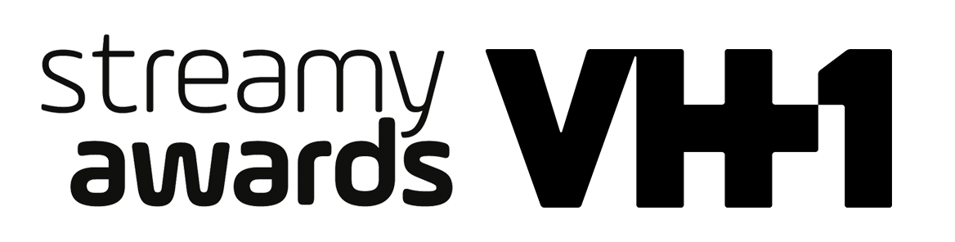

DICK CLARK PRODUCTIONS, TUBEFILTER, AND VH1 ANNOUNCE
THE 5TH ANNUAL STREAMY AWARDS TO BROADCAST LIVE
ON VH1 THURSDAY, SEPTEMBER 17, 2015 AT 10:00 PM ET/PT

2015 Submissions and Fan Nominations Open with New Categories

For Streamy Awards photos and video assets, please go to: http://bit.ly/StreamysContent

Los Angeles, CA (June 3, 2015) – dick clark productions, one of the world’s largest producers and proprietors of televised live event programming, Tubefilter, the leading resource for YouTube and online video news, analysis and events, and VH1, the renowned music and pop culture television network, have partnered for the first-ever television broadcast of the Streamy Awards. The 5th Annual Streamy Awards, honoring the best in online video and the creators behind it, will air live on VH1 and its digital platforms from the historic Hollywood Palladium on Thursday, September 17, 2015 at 10:00 pm ET/delayed PT.

“The VH1 audience is connected on every platform. So it’s a natural for VH1 to celebrate the innovators who, like us, entertain literally millions of viewers,” said Tom Calderone, President, VH1. “We couldn’t be more excited to partner with dick clark productions and Tubefilter on amplifying all of the amazing creativity of the past year by presenting the Streamy Awards for the first time ever on television.”
"Our partnership with VH1 is not only a huge milestone for the Streamy Awards, but also a triumph for the entire creator community," said Streamy Awards Creator Drew Baldwin. "Having the full support of such a major media network validates what we have believed all along—native digital creators are integral to the future of entertainment."

“dick clark productions and Tubefilter have grown the Streamy Awards to the point where it has become a benchmark of success—equally important to the industry, the creators, and the fans,” said Ariel Elazar, Senior Vice President of Digital for dick clark productions.
“We couldn’t imagine a better home for the Streamy Awards,” said Assaf Blecher, Vice President of Programming & Development for dick clark productions. “VH1 has always embraced cutting edge programming, which makes them the ideal partner for such an innovative show.”

Creator Submissions and Fan Nominations for the 5th Annual Streamy Awards open today at www.streamys.org and close 11:59 pm PT on Friday, June 26, 2015.

Continuing to reflect the current state of original programming native to online and social video, the 5th Annual Streamy Awards will feature new and updated awards, including:

- New subject awards for Lifestyle channels and Documentary or Investigative series.
- Breakout Creator and Breakthrough Artist awards recognizing up-and-coming digital creators and music artists who have not previously been nominated.
- Introduction of the Social Video category to include Instagram, Snapchat, and Vine.

The full list of awards categories for the 5th Annual Streamy Awards is available at: www.streamys.org/categories.

Fan Nominations will once again put fans at the heart of the official nominations process, by allowing them to publicly nominate their favorite creators and shows. The creator submission with the most fan nominations automatically becomes one of the five official nominees in each category. Two Audience Choice Awards—Entertainer of the Year and Show of the Year—are determined entirely by fan vote.

“More than ever before, audience engagement is critical to success in online video—wherever it may live,” added Streamy Awards Creator Josh Cohen. “Fans are a powerful voice, and will always play a major role in the Streamy Awards discovery and nominations process.”

Streamys winners are determined by the Streamys Blue Ribbon Panel, comprised of a select group of leaders shaping the future of entertainment. They include creators, executives, and other experts in the online video industry.
The 4th Annual Streamy Awards garnered more than 7 million views on YouTube, 2.8 million Vine loops in 24 hours, three worldwide trending topics on Twitter, driving more engagement than the top TV shows airing that night. Creators and fans generated more than 1 billion impressions around the show.
Join the conversation on Twitter with @streamys using #Streamys. Follow Streamy Awards on Facebook.
Cheat tweet: This year @dclarkp and @tubefilter are bringing the @Streamys to @VH1! Tune-in LIVE on 9/17 at 10PM ET|PT: bit.ly/Streamys2015 #streamys
About The Streamy Awards
Founded by Drew Baldwin and Joshua Cohen, the Streamy Awards honor the best in online video and the creators behind it. The annual event brings together the biggest names in YouTube and online video for a night of celebration, discovery, and meaningful recognition.

About dick clark productions
dick clark productions (dcp) is the world's largest producer and proprietor of televised live event entertainment programming with the “Academy of Country Music Awards,” “American Country Countdown Awards,” “American Music Awards,” “Billboard Music Awards,” “Dick Clark's New Year's Rockin’ Eve with Ryan Seacrest,” “Golden Globe Awards,” “Hollywood Film Awards” and “The PEOPLE Magazine Awards.” Weekly television programming includes SO YOU THINK YOU CAN DANCE from 19 Entertainment, a division of CORE Media Group, and dcp; WORLD’S FUNNIEST from Jukin Media and dcp; as well as BOOM! (FOX) from Keshet DCP, the joint venture between Keshet International (KI), the global distribution and production arm of Keshet Media Group, and DC Media, the parent company of dcp. dcp also owns one of the world's most unique and extensive entertainment archive libraries with more than 55 years of award-winning shows, historic programs, specials, performances and legendary programming. For additional information, visit www.dickclark.com.

About Tubefilter
Tubefilter is the leading resource for YouTube and online video news, analysis, and events, including the Streamy Awards (streamys.org) and Stream Con NYC (streamconnyc.com). For additional information, visit www.tubefilter.com.

About VH1
VH1 delivers the ultimate mash-up of music, pop culture and nostalgia for adults who still want to have fun. VH1 is available in 93 million households in the U.S. VH1 also has an array of digital channels and services including VH1 Classic, VH1 Soul, the VH1 App, VH1.com and @VH1, the hub for all things music and pop culture. Fans may also access current and retro VH1 programming via the VH1 App, the network's three-in-one video, new form content and co-viewing app, available for free on iOS and Android platforms. VH1 is a unit of Viacom Inc. (NASDAQ: VIA, VIAB), one of the world's leading creators of programming and content across all media platforms. For more information, go to www.vh1press.com, VH1.com, or the VH1 Facebook page. Follow us on Twitter @VH1PR.

Media Contacts:

dick clark productions
Liz Morentin, 310-255-4602, lmorentin@dickclark.com
Gina Sorial, 310-255-0308, gsorial@dickclark.com

MPRM Communications
Karlyn Nelson, 323-933-3399, knelson@mprm.com
Michelle Marron, 323-933-3399, mmarron@mprm.com

VH1
Chris Delhomme, 310-752-8635, Chris.Delhomme@VH1.com
Toni Herron-Savage, 212-846-7528, Toni.Herron@VH1.com

# # #

The 5th Annual Streamy Awards recognize excellence across forty-four categories, including two Audience Choice Awards chosen entirely by members of the public.

Overall (9)
Animated
Breakout Creator (New Category)
Comedy
Drama
First Person
Indie
International
Non-Fiction
Spin-Off

Subject (13)
Action or Sci-Fi
Beauty
Documentary or Investigative (New Category)
Fashion
Food
Gaming
Health and Wellness
Kids and Family
Lifestyle (New Category)
News and Culture
Pranks
Science or Education
Sports

Performance (5)
Actor
Actress
Collaboration
Dance
Ensemble Cast

Music (3)
Breakthrough Artist (New Category)
Cover Song
Original Song

Craft (6)
Cinematography
Costume Design
Directing
Editing
Visual and Special Effects
Writing

Social Video (4)
Short Form Comedy (New Category)
Short Form Creativity (New Category)
Snapchat Storyteller (New Category)
Viner

Campaign (2)
Brand Campaign
Social Good

Audience Choice (2)
Entertainer of the Year
Show of The Year

