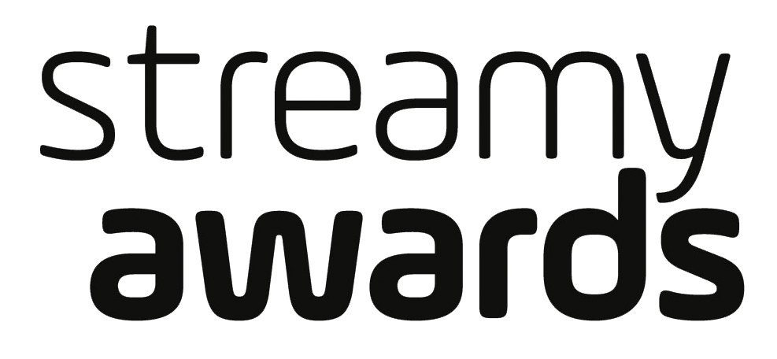

VILLAGE PEOPLE TO PERFORM
AT THE 7TH ANNUAL STREAMY AWARDS
WITH ORIGINAL LEAD SINGER VICTOR WILLIS BACK
AT THE HELM FOR THE GROUP’S 40TH ANNIVERSARY

The Legendary Group Will Perform a Medley of Their Biggest Hits

The 7th Annual Streamy Awards will be streamed LIVE on Twitter on Tuesday, September 26, 2017 at 9:30PM ET / 6:30PM PT from The Beverly Hilton

Fan Voting for Creator of the Year and Show of the Year Now Open

For AMAZING Streamy Awards + Village People photos and video assets, please go to: http://bit.ly/Streamys17

SANTA MONICA, CA (September 13, 2017) – dick clark productions and Tubefilter announced today that iconic 70’s disco group, Village People, will close out the night with a medley of their most beloved songs at the 7th Annual Streamy Awards. This will mark the first time that group founder and original lead singer and writer Victor Willis will perform with the group since the mid-1980s! Willis, whose powerful voice is synonymous with all the Village People hits, revamped the group lineup this year, including the addition of an Asian-American for the first time in the group’s history. The 2017 Streamy Awards will take place at the iconic Beverly Hilton on Tuesday, September 26 at 9:30PM ET / 6:30PM PT and stream LIVE on Twitter.

“It’s hard to believe that it’s been 40 years since I recorded the first Village People album. So we look forward to our performance on the Streamys, carried live via Twitter, with a new generation of fans highly driven by social media platforms,” said Victor Willis.

Additionally, fan voting for the two Audience Choice categories – Creator of the Year and Show of the Year - is now open. Fans can vote once per day per category by tweeting out a nominee’s specific hashtag. Voting for both categories will close at 7PM PT on Tuesday, September 26, which is 30 minutes into the live stream of the 7th Annual Streamy Awards. Fans should be sure to only include one of the below hashtags per voting tweet!

Creator of the Year:

Cameron Dallas - #CameronForStreamys
Casey Neistat - #CaseyForStreamys
David Dobrik - #DavidForStreamys
Dolan Twins - #DolanForStreamys
Jake Paul - #JakeForStreamys
Jenna Marbles - #JennaForStreamys
Lilly Singh - #LillyForStreamys
Liza Koshy - #LizaForStreamys
Logan Paul - #LoganForStreamys
Shane Dawson - #ShaneForStreamys

Show of the Year:

Good Mythical Morning - #GMMForStreamys
Kian & JC - #KianJCForStreamys
The King of Random - #TKORForStreamys
The Philip DeFranco Show - #DeFrancoShowForStreamys
REACT - #REACTForStreamys
Rooster Teeth - #RoosterTeethForStreamys
Sugar Pine 7 - #SP7ForStreamys
The Try Guys - #TryGuysForStreamys
UNHhhh - #UNHhhhForStreamys
The Young Turks - #TYTForStreamys

Village People is one of the most iconic music groups in the world. For 40 years, the music of Village People has put a smile on the faces of fans all around the world. Their hits have become part of the international songbook and heard across the globe in numerous television commercials and motion pictures. . In fact, Y.M.C.A. (along with its dance) is features at almost every party, wedding, bar mitzvah, and sporting event.

With hits like San Francisco/In Hollywood, Macho Man, YMCA, In the Navy, and Go West, the group sold more than 100 million records worldwide and earned many awards including the American Music Award-Favorite Musical Group 1979. Village People were featured on the cover of Rolling Stone.

Village People is: Victor Willis (Cop/Admiral), Angel Morales (Native American), James Kwong (Construction Worker), Chad Freeman (Cowboy), Sonny Earl (G.I.), and Jeffrey Lippold (Leatherman).

The nominees of the 7th Annual Streamy Awards were announced last month. YouTube personality and filmmaker Casey Neistat and go90’s original series Mr. Student Body President led with six nominations each. DeStorm Power’s independent drama series Caught, actor, comedian and author Lilly Singh, and Steven Suptic’s breakout show Sugar Pine 7 garnered four nominations each.

Winners of the Streamy Awards will be determined by the Streamys Blue Ribbon Panel, a judging body of creators, executives, and other experts in the online video industry. Fans will be able to vote for their favorite nominees in the two Audience Choice categories – Creator of the Year and Show of the Year – leading up to the live show on September 26.

Continuing to reflect the current state of original programming native to online and social video, the 7th Annual Streamy Awards have made the following updates, including:
- An expansion of the Branded and Social Good categories, including the establishment of “The Purpose Awards,” which takes place during Streamy week on Sept. 25.
- Greater emphasis on original series with the addition of Comedy and Drama Series awards
- The removal of gender distinction in the performance categories
- Select categories encompassed submissions from creators who distribute video primarily via social media platforms
The live stream of the 6th Annual Streamy Awards garnered over 750,000 views, a 128% increase over the prior year. Additionally, over 6.8MM total votes were cast for the Audience Choice categories at the 6th Annual Streamy Awards, which was an 81% increase from the year prior.
The 7th Annual Streamy Awards is Executive Produced by dick clark productions’ Allen Shapiro, Mike Mahan and Ariel Elazar, as well as Streamy Awards founders Drew Baldwin and Joshua Cohen. Producers include dick clark productions’ Rika Camizianos, Alexi Mazareas and Michael Nieporent.

For more information, visit www.streamys.org. Join the conversation on social media with #streamys and be sure to follow Streamy Awards on Facebook, Twitter, Instagram, Tumblr, and Snapchat.

Cheat Tweet: .@WeVillagePeople will perform at the @streamys with original lead singer @victorwillis for their 40th anniversary: http://streamys.news/villagepeople

About the Streamy Awards
The Streamy Awards honor the best in online video and the creators behind it. The annual event brings together the biggest names in YouTube and online video for a night of celebration, discovery, and meaningful recognition. 2017 also marks the first ever installment of ““The Purpose Awards @ The Streamy Awards,” an annual event recognizing individuals and organizations making a difference in their communities and positively impacting humankind.

About dick clark productions
dick clark productions (dcp) is the world's largest producer and proprietor of televised live event entertainment programming with the "Academy of Country Music Awards," "American Music Awards," "Billboard Music Awards," "Dick Clark's New Year's Rockin' Eve with Ryan Seacrest," "Golden Globe Awards," “Miss America,” “Hollywood Film Awards” and the “Streamy Awards.” Weekly television programming includes "So You Think You Can Dance" from 19 Entertainment and dcp. dcp also owns one of the world's most unique and extensive entertainment archive libraries with more than 55 years of award-winning shows, historic programs, specials, performances and legendary programming. For additional information, visit www.dickclark.com.

About Tubefilter
Tubefilter is the most trusted and widely read source for YouTube and online video news, analysis, and events. Through its trade news and analysis, community events, and creator advocacy programs, Tubefilter has helped to foster the growth, promotion, and legitimization of a new, independent professional entertainment industry. Tubefilter properties include its flagship publication, Tubefilter News, the Tubefilter Charts, its popular YouTube Millionaires series, and the Streamy Awards. For additional information, visit www.tubefilter.com.

# # #

For Show Media Credentials:
To apply for media credentials to cover the 7th Annual Streamy Awards, please click HERE and fill out the online form.

For Other Press Inquiries:
SLATE PR
Andy Gelb, 310-461-0111, andy@slate-pr.com
Elyse Weissman, 310-461-0114, elyse@slate-pr.com

dick clark productions
Kelly Striewski, 310-255-4602, kstriewski@dickclark.com
Allie Stockton, 310-255-0321, astockton@dickclark.com

For Talent Booking:
Krissy Lindquist, 310-255-4671, krissylindquist@gmail.com

To Purchase Tickets, Tables or Partnership Opportunities:
Marisa Pratt, 310-255-4618, mpratt@dickclark.com

