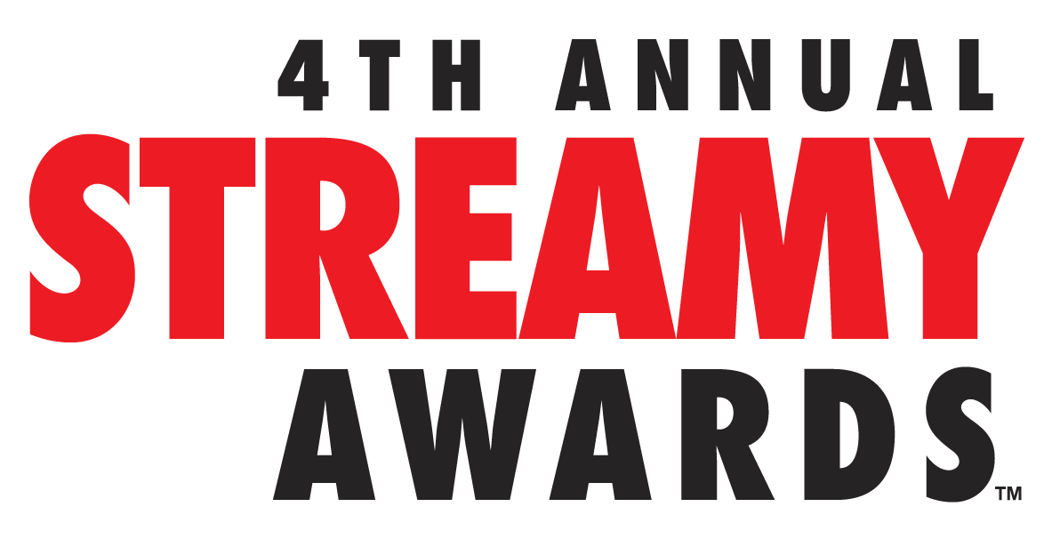

PRE-LIVE STREAM WINNERS ANNOUNCED FOR THE
4TH ANNUAL STREAMY AWARDS PRESENTED BY COCA-COLA

4TH Annual Streamy Awards Presented by Coca-Cola to Stream LIVE on Sunday, September 7, 2014 from The Beverly Hilton at 7:30 PM PT at www.streamys.org

SANTA MONICA, CA (September 4, 2014) – dick clark productions and Tubefilter announced today the list of pre-live stream winners of the 4th Annual Streamy Awards Presented by Coca-Cola. The pre-live stream winners were announced on September 4th during the Official Streamys Nominee Reception presented by What’s Trending and New Form Digital at the YouTube Space LA in Playa Vista, California. Fourteen other categories including Best First-Person Series, Best Comedy Series, Viner of the Year and Audience Choice Awards will be announced LIVE from The Beverly Hilton in Beverly Hills, California on Sunday, September 7, 2014 at 7:30PM PT/ 10:30PM ET at www.streamys.org.

This year’s Streamy Awards will be hosted by comedians Grace Helbig and Hannah Hart and feature musical performances by Pentatonix, Postmodern Jukebox and Starship. Set to present are the biggest stars in the world of live entertainment including Ashley Clements, Marmie Hart, Joey Graceffa, Ian Ziering, Tara Reid and Lance Bass. Additionally, Pitbull, Michelle Phan, Tyler Oakley and Shay Carl will receive the inaugural Streamys ICON Awards Presented by Samsung for their achievement in online video and entertainment.

Pre-live stream winners of the 4th Annual Streamy Awards include:

Channel, Show or Series – Overall
Best Companion (Channel, Show or Series) – Vandaveon and Mike (Key & Peele)
Best Non-Fiction or Reality (Channel, Show or Series) – Comedians in Cars Getting Coffee

Channel, Show or Series – Subject
Best Dance (Channel, Show or Series) – Jabbawockeez
Best Food and Cuisine (Channel, Show or Series) – Epic Meal Time
Best Health and Wellness (Channel, Show or Series) – Blogilates
Best Pranks (Channel, Show or Series) – Jack Vale
Best Science and Education (Channel, Show or Series) - Vsauce
Best Sports (Channel, Show or Series) – Red Bull

Special
Best Animated (Channel, Show or Series) – RWBY
Best Indie (Channel, Show or Series) – Little Horribles
Best International (Channel, Show or Series) – Noob (France)

Performance
Best Actress in a Comedy – Mamrie Hart, You Deserve A Drink
Best Actress in a Drama – Ashley Clements, The Lizzie Bennet Diaries
Best Actor in a Comedy – David Milchard, Convos with My 2-Year-Old
Best Actor in a Drama – Joey Graceffa, Storytellers
Best Collaboration – Zach Galifianakis and President Barack Obama, Between Two Ferns

Music
Best Cover Song – Pentatonix, Daft Punk Mashup (Daft Punk)
Best Music Video – Goku vs Superman, Epic Rap Battles of History
Best Musical Artist, Lindsey Stirling

Craft
Best Choreography – Mortal Kombat: Legacy II, Garrett Warren and Larnell Stovall
Best Cinematography – Devinsupertramp, Devin Graham
Best Costume Design – Epic Rap Battles of History, Sulai Lopez
Best Directing – Video Game High School, Matt Arnold and Freddie Wong
Best Editing – Kids React, Dan Seibert, Justin Reager, Benny Fine, Rafi Fine, and Jordan Towles
Best Original Score – RWBY, Jeff Williams
Best Visual and Special Effects – Action Movie Kid, Daniel Hashimoto
Best Writing – Epic Rap Battles of History, Nice Peter, EpicLLOYD, Zach Sherwin, Dante Cimadamore, and Mike Betette

Vine
Best Vine Comedian – DeStorm Power
Best Vine Creativity – Zach King

Campaign or Event
Best Brand Campaign – Need For Speed: Ken Block’s Gymkhana Six (Need For Speed)
Best Live Event – #Tubeathon 2013
Best Public Service – YouTube Stars Talk Health Care at the White House

Television
Best Television Show – Tonight Show Starring Jimmy Fallon

The 4th Annual Streamy Awards Presented by Coca-Cola is produced by dick clark productions. Assaf Blecher, Vice President of Programming and Development at dick clark productions, and Drew Baldwin and Joshua Cohen, co-founders of Tubefilter, are Executive Producers.

About The Streamy Awards
The Streamy Awards honor the best in online video and the creators behind it. The annual event brings together the biggest names in YouTube and online video for a night of celebration, discovery, and meaningful recognition.

About dick clark productions
dick clark productions (dcp) is among the world's largest producers and proprietors of televised live event programming. dcp produces perennial hits such as the "American Music Awards," "Golden Globe Awards," "Academy of Country Music Awards," "Billboard Music Awards," and "Dick Clark's New Year's Rockin' Eve with Ryan Seacrest." Weekly television programming, includes "So You Think You Can Dance" from 19 Entertainment, a division of CORE Media Group, and dick clark productions; as well as "Rising Star" and the upcoming “Boom!” from Keshet DCP, the joint venture between Keshet International (KI), the global distribution and production arm of Keshet Media Group, and DC Media, the parent company of dick clark productions (dcp). In 2014, dcp will debut the "American Country Countdown Awards" (FOX), “Hollywood Film Awards (CBS) and "The PEOPLE MAGAZINE Awards" (NBC). dcp also owns one of the world's mostunique and extensive entertainment archive libraries with more than 55 years of dcp's award-winning shows, historic programs, specials, performances, and legendary programming. For additional information, visit www.dickclark.com.
About Tubefilter
Tubefilter is the leading source for YouTube and online video industry news, reviews, and events. For additional information, visit www.tubefilter.comand follow @tubefilter on Twitter.
###

Media Contacts:

Gina Sorial
dick clark productions GSorial@dickclark.com

Dana Block
Allison&Partners Dana@allisonpr.com

